PROJECT / CONFERENCE AREA

YOU ARE STANDING HERE
ROOM D
8,3
meters
3,55 meters

6,6meters

, meters
4 meters

ROOM C
6,2

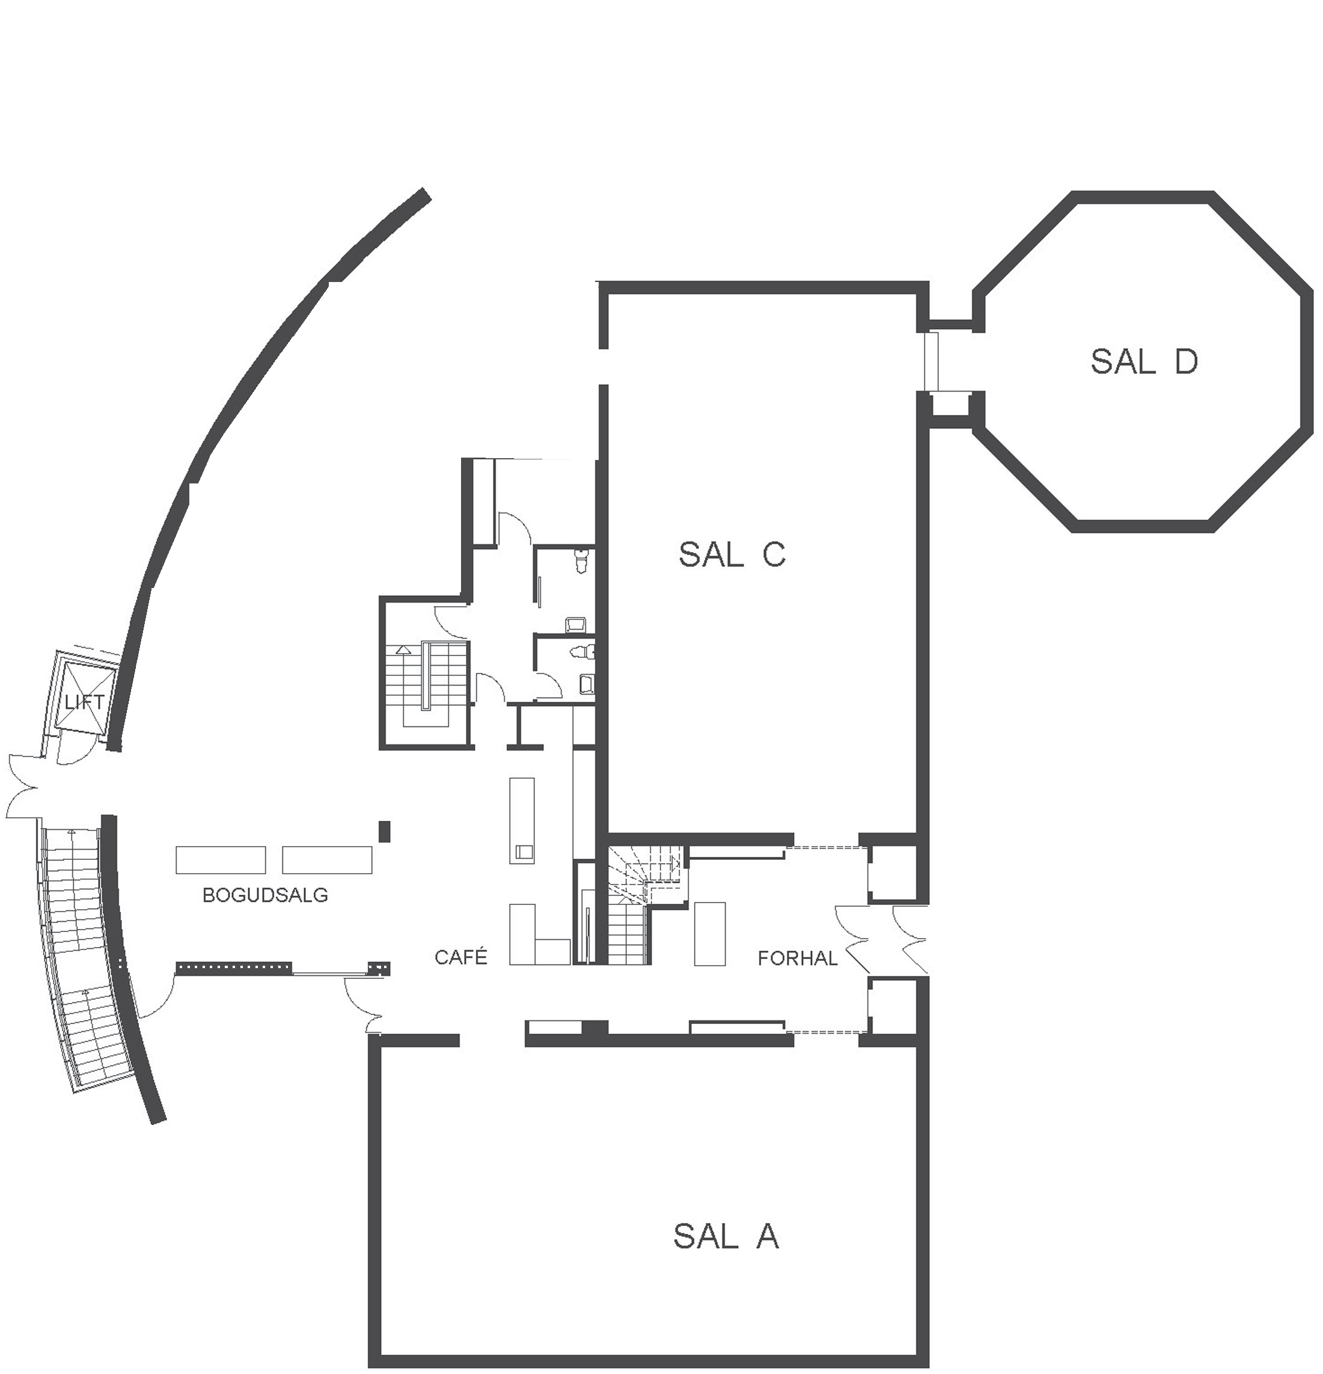


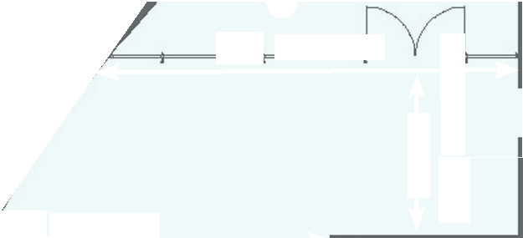



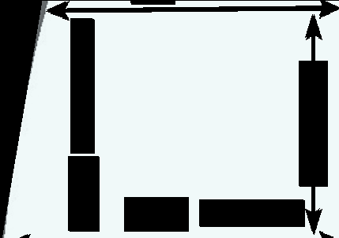





7,14
7,14
meters
4,26 meters

LIBRARY HALL

ROOM A

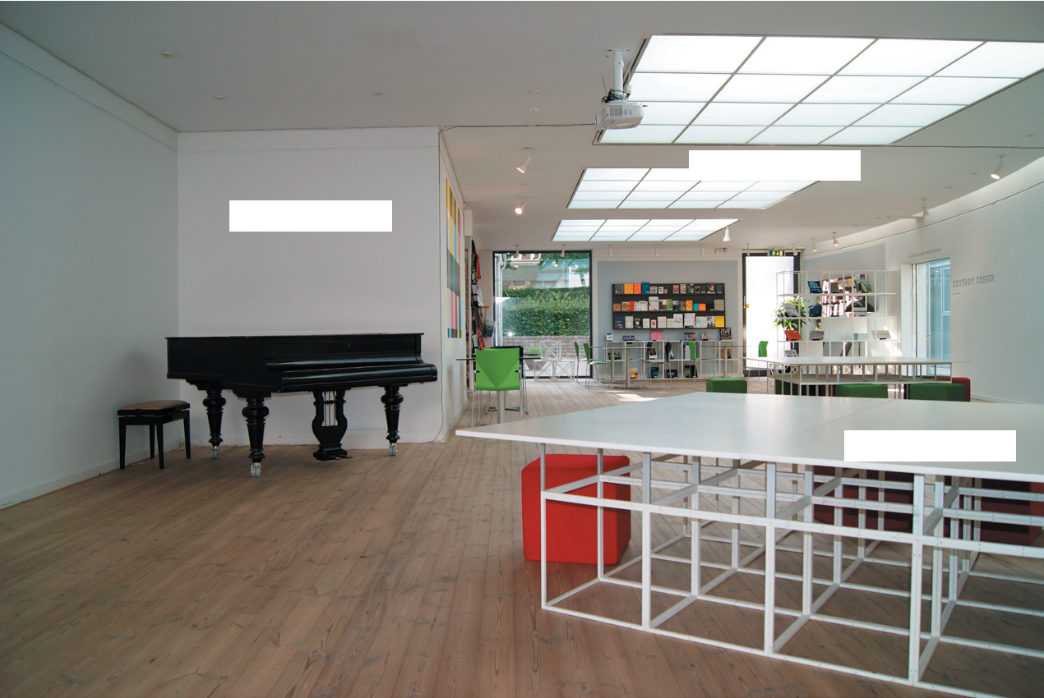



7,14 meter
2,65meter
6,60 meter

